Lab Safety
Name:__________________________________________
- Mrs. Valentas’ Lab Rules and Expectations
  - Act Responsibly
    - You must act _______________ and _______________ during all labs.
    - You are to remain at your _______________, pay _______________ at all times, and _______________ on your work.
    - No _______________, no _______________, and no _______________ _______________
  - Listen
    - Listen to the teacher’s _______________ at all times
  - Be Prepared
    - _______________ all lab material prior to the lab day
    - _______________ _______________must be tied back
    - Appropriate attire must be worn at all times
      - Shorts must come to ______-_______________
      - T-shirts must have _______________
      - _______________ _______________must be worn at all times
  - Handle With Care
    - All information discussed/obtained during lab must be kept _______________.
    - Treat all _______________ and _______________ with care! Do not _______________ any equipment!
    - Do not _______________ any_______________or _______________until the teacher tells you to begin.
    - If something appears _______________…call the teacher!
    - Do not place a _______________ _______________where someone can trip.
  - Keep it out of lab
    - No _______________, _______________, or _______________ _______________!
      - _______________ _______________is acceptable
    - _______________ _______________are not permitted in lab.
  - Let Mrs. Valentas Know:
    - If you have any _______________, ask!
    - If there is an _______________ (no matter how small), let the teacher know right away!
    - Check __________ _______________prior to beginning and _______________ any _______________ to your teacher immediately.
    - If you begin to feel ______- _______________, _______________ or_______________let the teacher know immediately.
  - Clean Up
    - Wipe down ___________ _______________with antibacterial ___________ ____________.
    - Once your lab is complete, clean your _______________ _______________and make sure _______ _______________ is _______________in its _______________ _______________.
    - Leave the lab _______________ than it was when you _______________.
    - Dispose of any _______________ in the proper locations.
    - Wash your _______________ thoroughly with __________ and _______________.
  - Have fun and learn
    - Lab is a great opportunity to ______________principles of ______________ ______________.
    - Have fun _______________ and _______________what students in _______________ college!
    - It’s okay to make a _______________, that’s when _______________ _______________!

- What do you think is the most important safety rule and why?
____________________________________________________________________________________________________________________________________________________________________________________________________________________________________________________________________________________________________________________________________________________________________________

- What is the number one concern in a fitness center?

- What is included in fitness safety?
- ___________________________________ | - ___________________________________
- ___________________________________ | - ___________________________________
- ___________________________________ | - ___________________________________

- What pieces of cardiovascular equipment does FCC have?
- ___________________________________ | - ___________________________________
- ___________________________________

- Explain the difference between weight bearing and non-weight bearing exercise.
____________________________________________________________________________________________________________________________________________________________________________________________________________________________________________________________________________________________________________________________________________________________________________
____________________________________________________________________________________________________________________________________________________________________________________________________________________________________________________________________________________________________________________________________________________________________________

The following questions are related to treadmill operation and maintenance
Powerpoint can be found on: http://fcc-exercisescience1.weebly.com/classroom-and-lab-safety.html

- What is a treadmill?
______________________________________________________________________________________________________________________________________________________________________________________

- Complete the following timeline:
2000 B.C.
1818 A.D.
First US Patent of a treadmill training machine

Dr. Robert Bruce began using exercise treadmills to diagnose heart and lung disease

1968
1969
1982
Dr. Seth Roberts designed a treadmill desk, allowing people that normally sit at a work station to walk at very slow speeds while completing their tasks. Some users can walk up to 6 miles per day.

- Where are treadmills used today?
- ___________________________________ | - ___________________________________
- ___________________________________ | - ___________________________________
- ___________________________________ | - ___________________________________
- ___________________________________ | - ___________________________________
- ___________________________________ | - ___________________________________
- ___________________________________

- What is manual locomotion therapy?
______________________________________________________________________________________________________________________________________________________________________________________

- What are the advantages and disadvantages to treadmill use?
Advantages | Disadvantages
- ___________________________________ ___________________________________ | - ___________________________________ ___________________________________
- ___________________________________ ___________________________________ | - ___________________________________ ___________________________________
- ___________________________________ ___________________________________ | - ___________________________________ ___________________________________
- ___________________________________ ___________________________________ | - ___________________________________ ___________________________________
- ___________________________________ ___________________________________

- ___________________________________ ___________________________________

- What are the safety and injury concerns for using a treadmill?
  - Dizziness:
______________________________________________________________________________________________________________________________________________________________________________________________________________________________________________________________________________________________________________________________________________________________________________________________________________________________________________________________________________________________________________________________

  - Falls:
____________________________________________________________________________________________________________________________________________________________________________________________________________________________________________________________________________________________________________________________________________________

  - Friction burn:
____________________________________________________________________________________________________________________________________________________________________________________________________________________________________________________________________________________________________________________________________________________

  - Lower body injuries:
____________________________________________________________________________________________________________________________________________________________________________________________________________________________________________________________________________________________________________________________________________________

  - Upper body injuries:
____________________________________________________________________________________________________________________________________________________________________________________________________________________________________________________________________________________________________________________________________________________

  - Hand Injuries:
____________________________________________________________________________________________________________________________________________________________________________________________________________________________________________________________________________________________________________________________________________________

- What can be done to prevent treadmill injuries?
  - _____________________________________________________________________________________
  - _____________________________________________________________________________________
  - _____________________________________________________________________________________
  - _____________________________________________________________________________________
  - _____________________________________________________________________________________
  - _____________________________________________________________________________________
  - _____________________________________________________________________________________

- What is proper body alignment when using a treadmill?
  - _____________________________________________________________________________________
  - _____________________________________________________________________________________
  - _____________________________________________________________________________________
  - _____________________________________________________________________________________

- Safety Considerations:
  - Never operate the treadmill if it has a _______________ _______________ or_______________, not working _______________ or if _______________ has been spilled on it.
  - Keep the cord away from _______________ _______________.
  - Never operate the treadmill with the _______ _______________blocked. Keep the air openings free of _______________, _______________ etc.
  - Never drop or insert any _______________ into any _______________.

  - Changes in _______________and _______________ do not occur immediately, the treadmill will adjust _______________.
  - Use caution while _______________g or _______________, distractions may cause you to _______________ _______________which could lead to _______________ _______________. NO _______________ _______________!
  - Do not use excessive pressure in the _______________ _______________ _______________.
  - _______________ _______________must be worn at all times.
  - Mandatory __________ _______________cool down on all programs.

- What programs do the treadmills have?
- ___________________________________ | - ___________________________________
- ___________________________________ | - ___________________________________
- ___________________________________ | - ___________________________________

- Getting started:
  - Turn the _______________ _______________on (located on the front of the treadmill below the _______________ _______________). _______________ _______________must be installed or the treadmill will not work without it.
  - When _______________ is turned on all the _______________ on the display will light for a short time.
  - Treadmill will then enter _______________ _______________, this is the _______________ _______________for operation.

- Treadmill users will clean the equipment after _____________ _____________with a _________ __________ and _______________any _______________. Additionally, students will complete a _______________ _______________of the treadmill weekly.

- What is cleaned after every use?
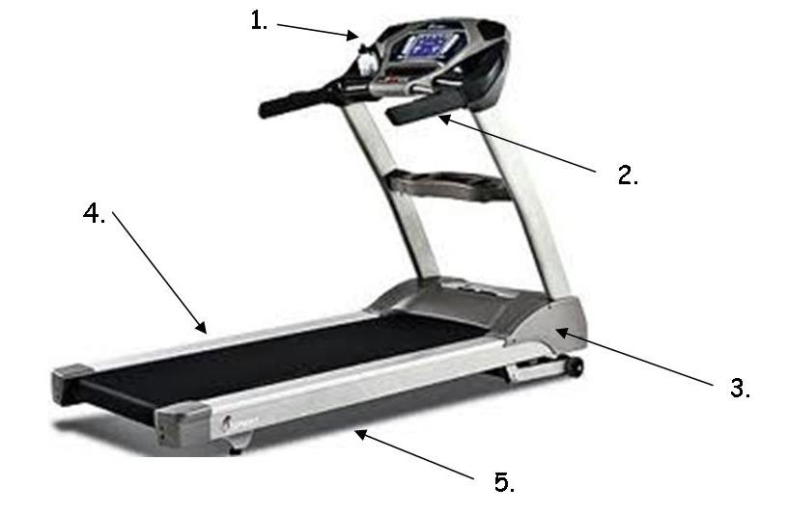
1. | __________________________________
2. | __________________________________
3. | __________________________________
4. | __________________________________
5. | __________________________________

- What is cleaned during deep cleaning?
1. | __________________________________
2. | __________________________________
3. | __________________________________
4. | __________________________________
5. | __________________________________
6. | __________________________________

The following questions are related to Elliptical operation and maintenance
- What is an elliptical?
______________________________________________________________________________________________________________________________________________________________________________________

- When did Elliptical trainers first enter the market?

- What are the benefits of using an elliptical machine?
  - _____________________________________________________________________________________
  - _____________________________________________________________________________________
  - _____________________________________________________________________________________

- What are the safety and injury concerns for using an elliptical?
  - Numbness in the feet:
____________________________________________________________________________________________________________________________________________________________________________________________________________________________________________________________________________________________________________________________________________________

  - Falls:
____________________________________________________________________________________________________________________________________________________________________________________________________________________________________________________________________________________________________________________________________________________

  - Upper body injuries: ____________________________________________________________________________________________________________________________________________________________________________________________________________________________________________________________________________________________________________________________________________________

- What is proper body alignment when using an elliptical?
  - _____________________________________________________________________________________
  - _____________________________________________________________________________________
  - _____________________________________________________________________________________
  - _____________________________________________________________________________________

- Safety Considerations:
  - Keep hands away from all _______________ _______________
  - Never operate the elliptical if it has a _______________ _______________ or_______________, not working _______________ or if _______________ has been spilled on it.
  - Keep the cord away from _______________ _______________.
  - Never drop or insert any _______________ into any _______________.
  - To disconnect, turn all controls to the _______________ _______________, then remove the plug from the outlet.
  - Use caution while using the elliptical, distractions may cause you to _______________ _______________which could lead to _______________ _______________. NO _______________ _______________!
  - Do not use excessive pressure in the _______________ _______________ _______________.
  - Wear proper ______________. High heels, dress shoes, ______________ or ______________ ______________are not suitable for use on the elliptical. Quality athletic shoes are recommended to avoid _______________ _______________.
  - Mandatory __________ _______________cool down on all programs.

- What programs do the Elliptical have?
- ___________________________________ | - ___________________________________
- ___________________________________ | - ___________________________________
- ___________________________________ | - ___________________________________

- Getting started:
  - Turn the _______________ _______________on (located on the front of the elliptical below the _______________ _______________).
  - Step up onto the foot pedal closet to the _______________and then step onto the other foot pedal.
  - If you hear a squeak while on the elliptical clean the _______________ and _______________ of the elliptical with a _______________ _______________cloth and _______________ _______________.

- Elliptical users will clean the equipment after _______________ _______________with a _______________ _______________and _______________ any _______________. Additionally, students will complete a _______________ _______________ of the elliptical weekly.

The following questions are related to Rower operation and maintenance
- What is a rower?
______________________________________________________________________________________________________________________________________________________________________________________

- Complete the following timeline:
4th Century B.C.
1872 A.D.
First rower was created that could measure power output. It utilized a heavy solid iron flywheel

Norway creates a rower that utilizes hanging weights which allows power production to be calculated more efficiently

1980
1981

- What are the benefits of rowers?
  - _____________________________________________________________________________________
  - _____________________________________________________________________________________
  - _____________________________________________________________________________________

- What safety considerations exist for the rowing machine?
  - Clothing: _____________________________________________________________________________

_____________________________________________________________________________________

  - _____________________________________________________________________________________

  - _____________________________________________________________________________________

  - _____________________________________________________________________________________

  - _____________________________________________________________________________________
- Label the rowing action phases:
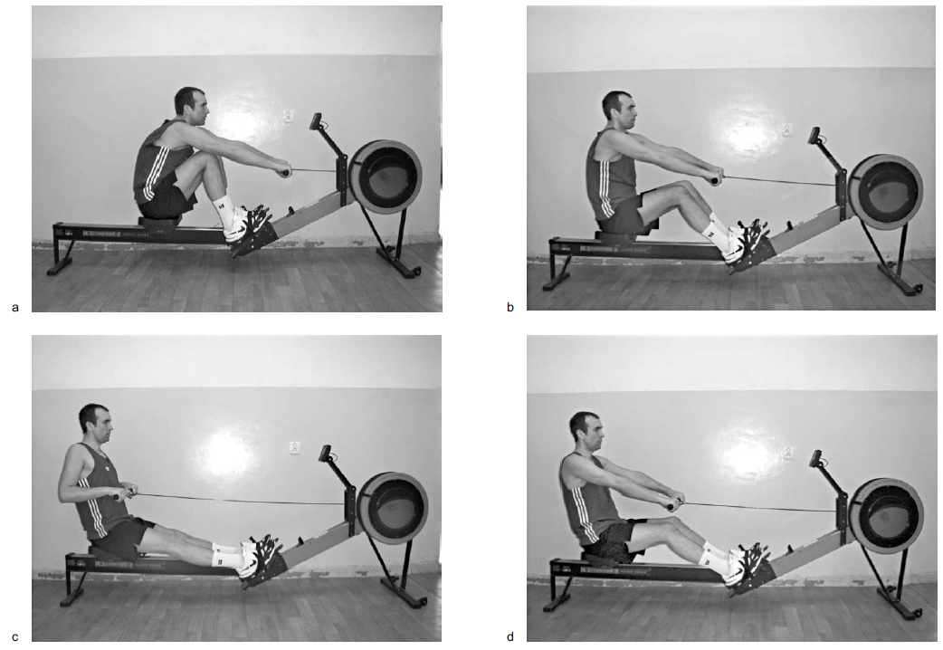
- ___________________________________ | - ___________________________________
- ___________________________________ | - ___________________________________

- What is proper body alignment during the rowing action phases?

Action phase | Alignment
Beginning
Drive
Extension
Ending

The following questions are related to Illness Prevention
- What areas within a gym hold the most germs?
Area | Reasons, tips and prevention
Dumbbells and other free weights | ________________ are among the most handled items in a fitness center  Carry risk for ________________ ________________, ________________ and ________________ infections
Cardio Equipment | ________________ and ________________are most common areas to hold germs.  Don’t use your ________________ to wipe away sweat, use a ________________instead
Shower and locker-room floors | Most common infection at the gym is ________________ _______________which thrives on ________________ ________________  Don’t go ________________ anywhere in the gym.  In locker rooms wear ________________ shoes and ________________ your feet well before putting on ________________ ________________and dry shoes
Mats | Germs that cause ________________, ________________ and ________________ infections like mats.  Use a ________________ wipe ________________ and ________________ using the mat to ________________ ________________
Water fountain | ________________ areas are the most contaminated areas  Don’t let your ______________ or ______________ touch the water fountain’s spout  Don’t ________________ into the water fountain  Don’t wipe your ________________ after sipping  If you use a water bottle clean it ________________
Your gym bag | ________________ are carried on clothing  Put ________________ and ________________ in a plastic bag inside your gym bag  Wash ________________ and ________________on a ________________ temperature wash cycle, don’t ________________dirty clothes  Wash your bag _______________ or at least spray it with a _______________spray

- What are daily cleaning procedures?
  - _____________________________________________________________________________________
  - _____________________________________________________________________________________

- Anyone that trains in a fitness facility, physical therapy clinic are at risk for _______________, _______________ and _______________ skin infections. _______________, _______________ and _______________ or _______________ contact with secretions of others make everyone’s skin vulnerable to a host of problems. Individuals who are _______________ should not train until after their doctor _______________ _______________them for exercise.

- What germs can be found in training facilities?
- ___________________________________ | - ___________________________________
- ___________________________________ | - ___________________________________
- ___________________________________ | - ___________________________________
- ___________________________________

- Answer the following questions related to the various germs that can be found in training facilities:
Germ | Klebsiella
What is it?
Symptoms
How do you get it?
How is it treated?
How to prevent it

Germ | E. Coli
What is it?
Symptoms
How do you get it?
How is it treated?
How to prevent it

Germ | Staphylococcus Aureus, commonly known as a staph infection
What is it?
Symptoms
How do you get it?
How is it treated?
How to prevent it

Germ | Human Papillomavirus, also known as HPV
What is it?
Symptoms
How do you get it?
How is it treated?
How to prevent it

Germ | Candida
What is it?
Symptoms
How do you get it?
How is it treated?
How to prevent it

Germ | Streptococcal Bacteria
What is it?
Symptoms
How do you get it?
How is it treated?
How to prevent it
Germ | Influenza, also known as the flu
What is it?
Symptoms
How do you get it?
How is it treated?
How to prevent it

- What are blood borne pathogens?
______________________________________________________________________________________________________________________________________________________________________________________

- What are the three most common blood borne pathogens?
- ___________________________________ | - ___________________________________
- ___________________________________

- Who is at risk for exposure to blood borne pathogens?
- ___________________________________ | - ___________________________________
- ___________________________________ | - ___________________________________
- ___________________________________ | - ___________________________________

- How can someone become infected with a blood borne pathogen?
  - _____________________________________________________________________________________
  - _____________________________________________________________________________________
  - _____________________________________________________________________________________

- Complete the following chart on blood borne pathogens
Blood borne Pathogen | Hepatitis B
What is it?
Symptoms
How do you get it?
How is it treated?
How to prevent it

Blood borne Pathogen | Hepatitis C
What is it?
Symptoms
How do you get it?
How is it treated?
How to prevent it

Blood borne Pathogen | Human Immunodeficiency Virus
What is it?
Symptoms
How do you get it?
How is it treated?
How to prevent it

- What are OSHA’s standard precautions?
  - Wear _______________ or _______________ gloves whenever touching _______- _______________ material such as open _______________, _______________, body _______________, or mucus _______________. Do not reuse _______________.
  - Wash hands with _______________ and ___________ _______________ immediately after they have been exposed to _______________ or body fluids, even if _______________ are worn.
  - All surfaces must be thoroughly _______________ after being soiled with blood or body fluid. Use a _______________ _______________ household bleach solution or a commercially available disinfectant.
  - Place all used _______________ in a special, _______________ _______________ sharps container.
  - Place all discarded _______________ _______________ in a specially labeled bio hazardous waste container.
  - When working _______________, dispose of medical waste by placing it in a _______________, _______________ biohazard bag and then discarding it in the proper biohazard waste container when returning indoors.
  - Do not allow athletes to _______________ _______________ that have been contaminated with blood or bodily fluids.
  - Put _______________ and _______________ that have been contaminated with blood or bodily fluids into a _______- _______________.
  - Be sure all _______________ are well covered.
  - If you have an _______________ _______________, especially if it is on your _______________, avoid providing first aid care for injuries that involve _______________or _______________ _______________until your wounds are healed. If you must do so, be sure to wear vinyl or latex gloves.
The following questions are related to Injury Prevention
- One of the personal trainer’s most _______________ _______________to clients is to _______________and _______________ their _______________ _______________to ensure _______________ _______________from resistance training in the _______________ _______________ _______________.

- Explain the different types of handgrips used when lifting:
  - Pronated: ____________________________________________________________________________
_____________________________________________________________________________________

  - Supinated: ____________________________________________________________________________
_____________________________________________________________________________________

  - Neutral: ______________________________________________________________________________
_____________________________________________________________________________________

  - Closed Grip: ___________________________________________________________________________
_____________________________________________________________________________________

  - Open Grip: ____________________________________________________________________________
_____________________________________________________________________________________

  - Alternated grip: ________________________________________________________________________
_____________________________________________________________________________________

- Label the following grips and indicated if the grip is open or closed:
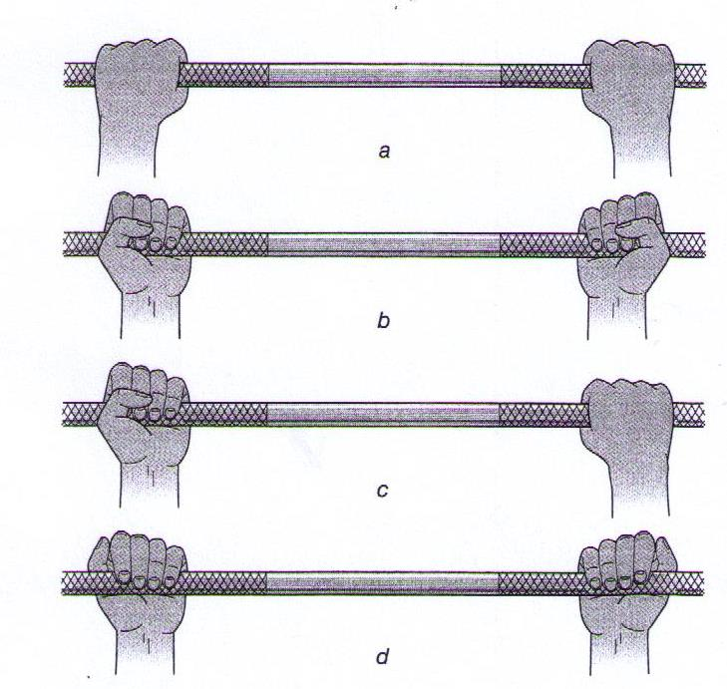
___________________________
___________________________
___________________________
___________________________

- Grips can be Wide, Shoulder Width, Hip Width and close as seen below.
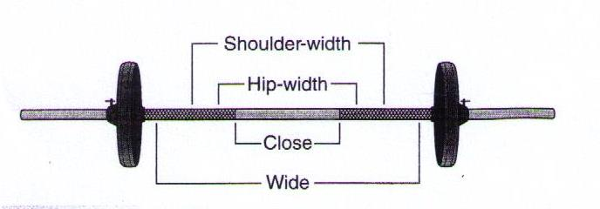

- When demonstrating a new exercise to a client the personal trainer should begin with how to _______________ a _______________ _______________. From this position, the client is able to maintain _______________ _______________ _______________ throughout the exercise, thereby placing stress only on the _______________ _______________.

- Explain starting potion for the following:
  - Standing exercises:
__________________________________________________________________________________________________________________________________________________________________________

  - Supine exercises (lying on back):
__________________________________________________________________________________________________________________________________________________________________________

  - Seated exercises:
__________________________________________________________________________________________________________________________________________________________________________

- Why is it important to remind clients to breathe?
_________________________________________________________________________________________________________________________________________________________________________________________________________________________________________________________________________________

- When should a personal trainer tell a client to breathe?
_________________________________________________________________________________________________________________________________________________________________________________________________________________________________________________________________________________

- What is the Valsalva maneuver?
_________________________________________________________________________________________________________________________________________________________________________________________________________________________________________________________________________________

- What are the four free weight exercise conditions that require a spotter?
  - _____________________________________________________________________________________
  - _____________________________________________________________________________________
  - _____________________________________________________________________________________
  - _____________________________________________________________________________________

- Why is the greater potential for serious injury with overhead or over the face exercises?
_________________________________________________________________________________________________________________________________________________________________________________________________________________________________________________________________________________

- Explain how to spot the following exercises:
  - Overhead and over the face:
    - Barbell: ________________________________________________________________________ ____________________________________________________________________________________________________________________________________________________________

    - Dumbbell: _____________________________________________________________________ ____________________________________________________________________________________________________________________________________________________________

    - Special consideration: ____________________________________________________________ ____________________________________________________________________________________________________________________________________________________________

  - When the bar is placed on upper back and shoulder or on front of shoulders and clavicle:
    - Barbell: ________________________________________________________________________ ____________________________________________________________________________________________________________________________________________________________

    - Special consideration: ____________________________________________________________ ____________________________________________________________________________________________________________________________________________________________

- Communication when spotting is the _______________ of both the_______________ and the _______________ _______________ . A client should be instructed to tell the personal trainer when he or she is _______________ to ______________the equipment into the starting position.

- What should personal trainers ask clients when preparing to spot?
  - _____________________________________________________________________________________
  - _____________________________________________________________________________________
  - _____________________________________________________________________________________

